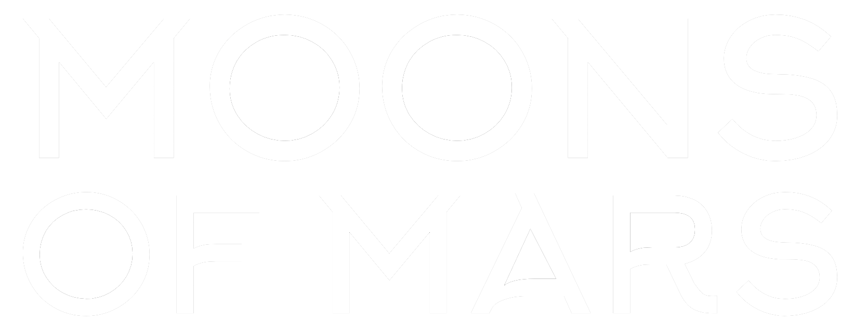

Design Report

# For the Moons of Mars Resort

Introduction to Web Design (DECO1400/7140)  
Semester 1, 2021

## By Nathan Hettige (46094511)

Part A

# Introducing the Design Report

This report was created to document the process of designing and implementing a website for the Moons of Mars Resort. This will provide the client with some insight into the decisions that were made and what consideration took place. A majority of the discussion will be reflective.

Included in this report will be an introduction to myself, the website topic, and the target audience. In addition to this, I completed four iterations of prototyping which included user testing, and evaluation of the feedback I received.

# Introducing the Web Designer

My name is Nathan, and I am the web designer and author of this design report. Currently I am a student studying a Bachelor of Computer Science with aspirations of becoming a cyber security specialist. Although I have been programming for some time, I do not have any experience in web design. I am coming into this project with knowledge of some basic HTML, and an understanding of what CSS and JavaScript can do.

As I do have experience with programming, I feel I already have an idea on how much time this project requires, where to get help, and where to start. The challenge for me will be going through the entire design process and appreciating the value of each iteration. I also have a focus on building good habits whilst learning these web languages. This means understanding separation of markup, style and behaviour, semantic and syntactic code quality and responsive design.

My learning strategy going into this course is to keep on top of the practicals and tutorials. Having done DECO subjects in the past, I’m aware of the implications of falling behind and would like to avoid that at all costs. I may not be able to complete everything to completion, but I will try my hand at every activity to ensure I’m not missing out on anything. Even if I’m unable to apply something I’ve learnt right away, the key is in knowing that it’s possible to recreate and where to find relevant resources.

Responding to the brief

# Introducing the Website Topic

I have chosen to present a website for the Moons of Mars resort.

This idea came into fruition whilst brainstorming what me and my friends would like to do on a vacation if weren’t bounded by reality. The goal was to come up with a place where we can relax, do amazing activities, and experience a life far from our current one. Similar to how cruise ships work, the resort had to be somewhere where customers can do whatever they please. With things like food, shelter and money already sorted out, the only thing left for the customer to do is rest, eat, explore new destinations, attend the virtually unlimited list of events, and try out the fun activities as many times as they please.

After reading the brief, I decided that I need to come up with something creative and compelling enough to engage the audience. I needed a thrilling location, exciting activities and plenty of attractive features.

The location was the first thing to settle. Initially we sampled a few earthly ideas like a campsite on the edge of a cliff, or even a chill spot in the clouds with magnificent views. Nevertheless, I didn’t think this was creative enough, and finally decided on the Moons of Mars. The main fuel for this idea is that the gravity is very different to that on earth and provides an opportunity to have a ‘floating vacation’. Mars also comes with its own dark red theme with imagery of the starry night.

The next major part of developing this idea was to come up with flagship activities to entice customers to visit. My focus was to invent three activities and a marketable name to match. There was not much of a process that went into to deciding the following activities: Guided Jetpack Tours, Xtreme Moon Climbing and Mars Sightseeing.

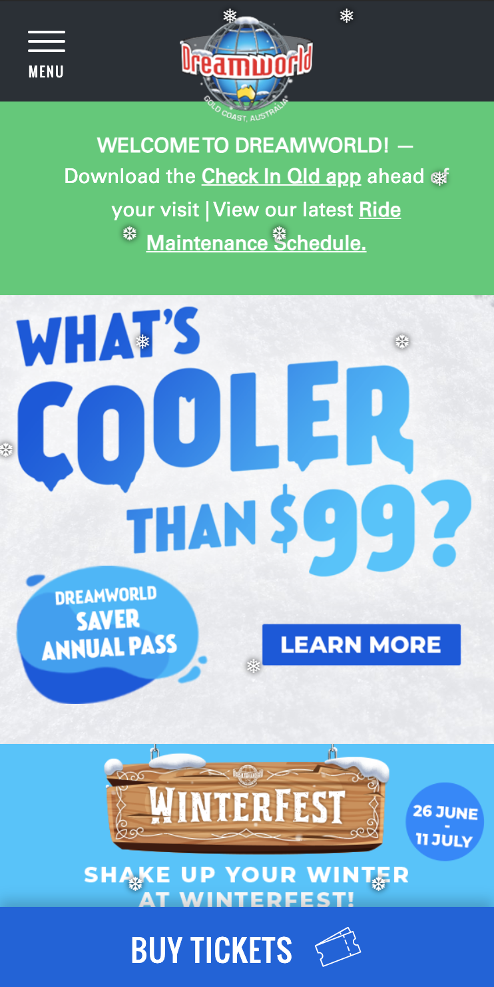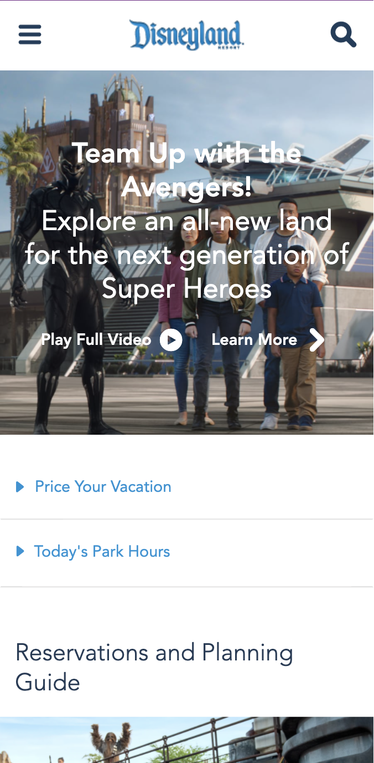In addition to these major activities, I also created a list of supporting features in order to pad the rest of the website with information regarding what a vacationer would typically expect from a resort. This included things like ‘Restaurants & Cafes’, ‘Nightlife’ and a ‘Zero Gravity Pool’. These will be displayed secondary to the major activities of the resort.

In terms of inspiration for the website, I started by looking at space related organisations and other themed resorts to see what kind of information my page will provide. Some of these Dreamworld, Disneyland and Heron Island. I noticed that many theme park/resort websites are visually organised the same; horizontal navigation bar followed an image and heading, and then introductions to the major selling points.

(Dreamworld, n.d.)

(Disney, n.d.)

Due to the lack of creativity in these pages, I had to look at some sites outside the scope of resorts for inspiration on the general aesthetic of the website. One page that definitely caught my eye was SpaceX. The pages were quite simple yet created an impressive interactive and immersive experience.

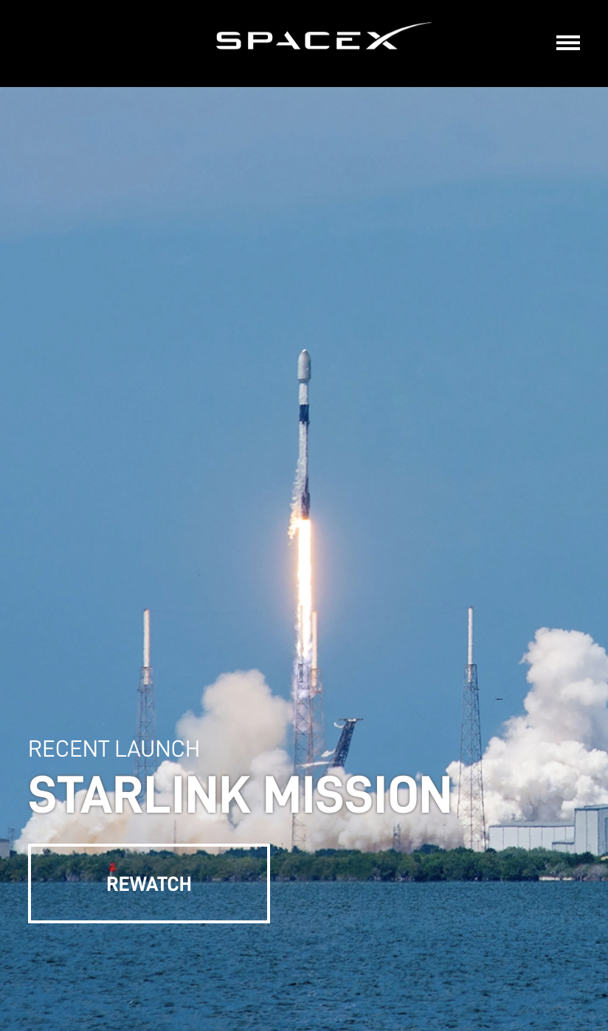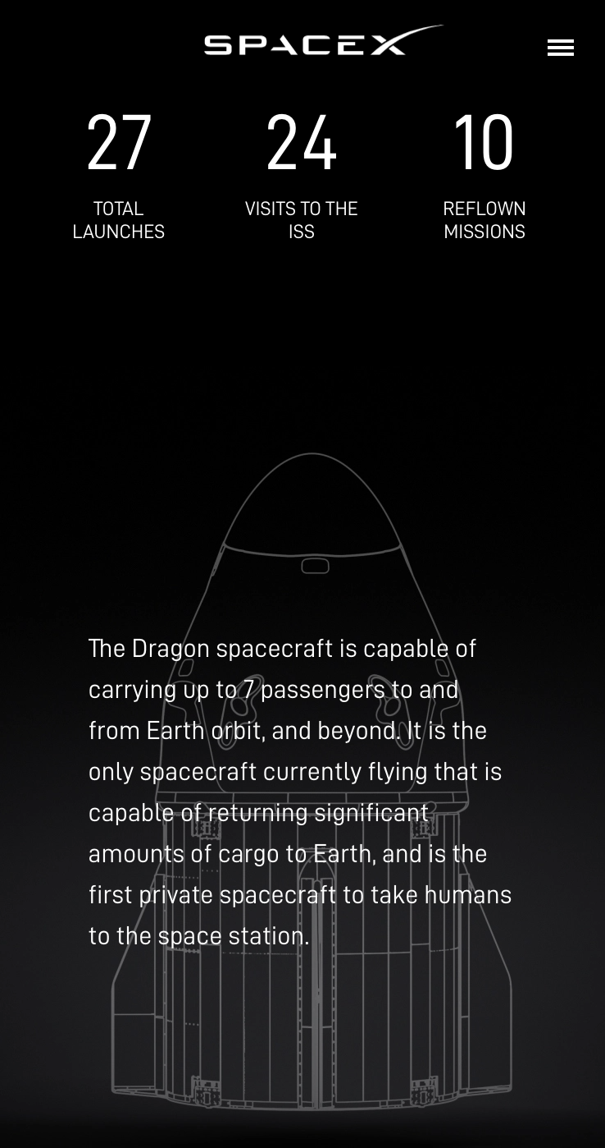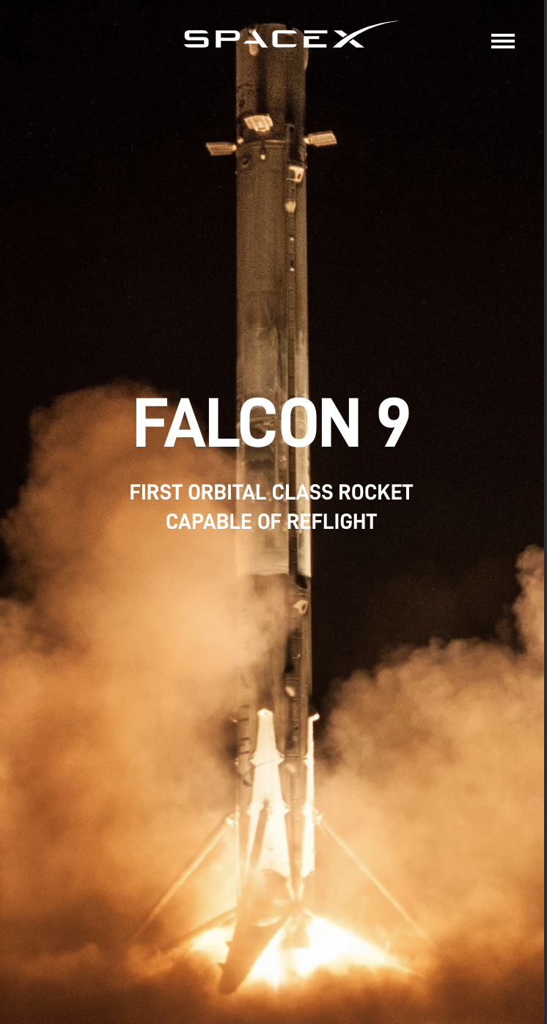 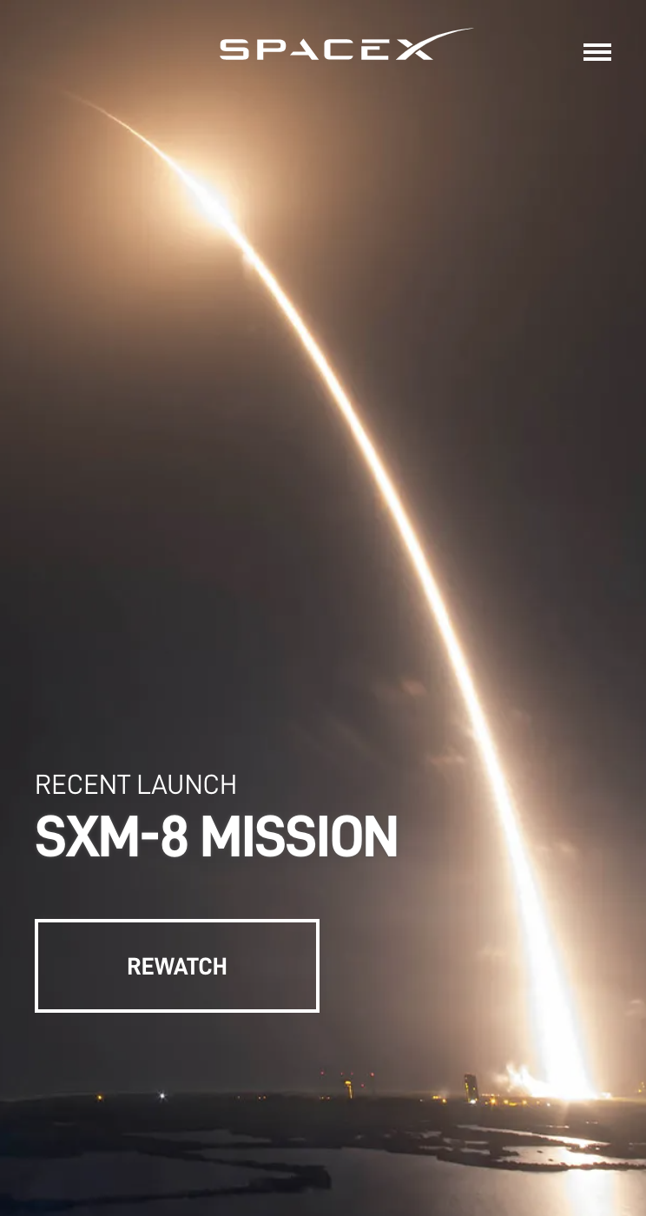

(SpaceX, n.d.)

What I liked about SpaceX in particular is how it uses space to bring focus to elements on the page. This can also be seen on the Tesla and Rolex website as well.

(Tesla, n.d.)

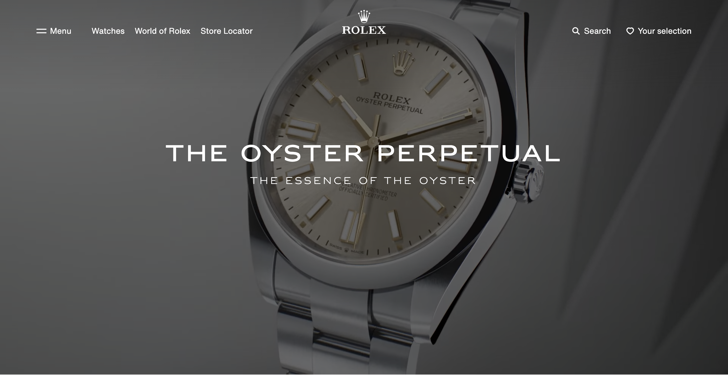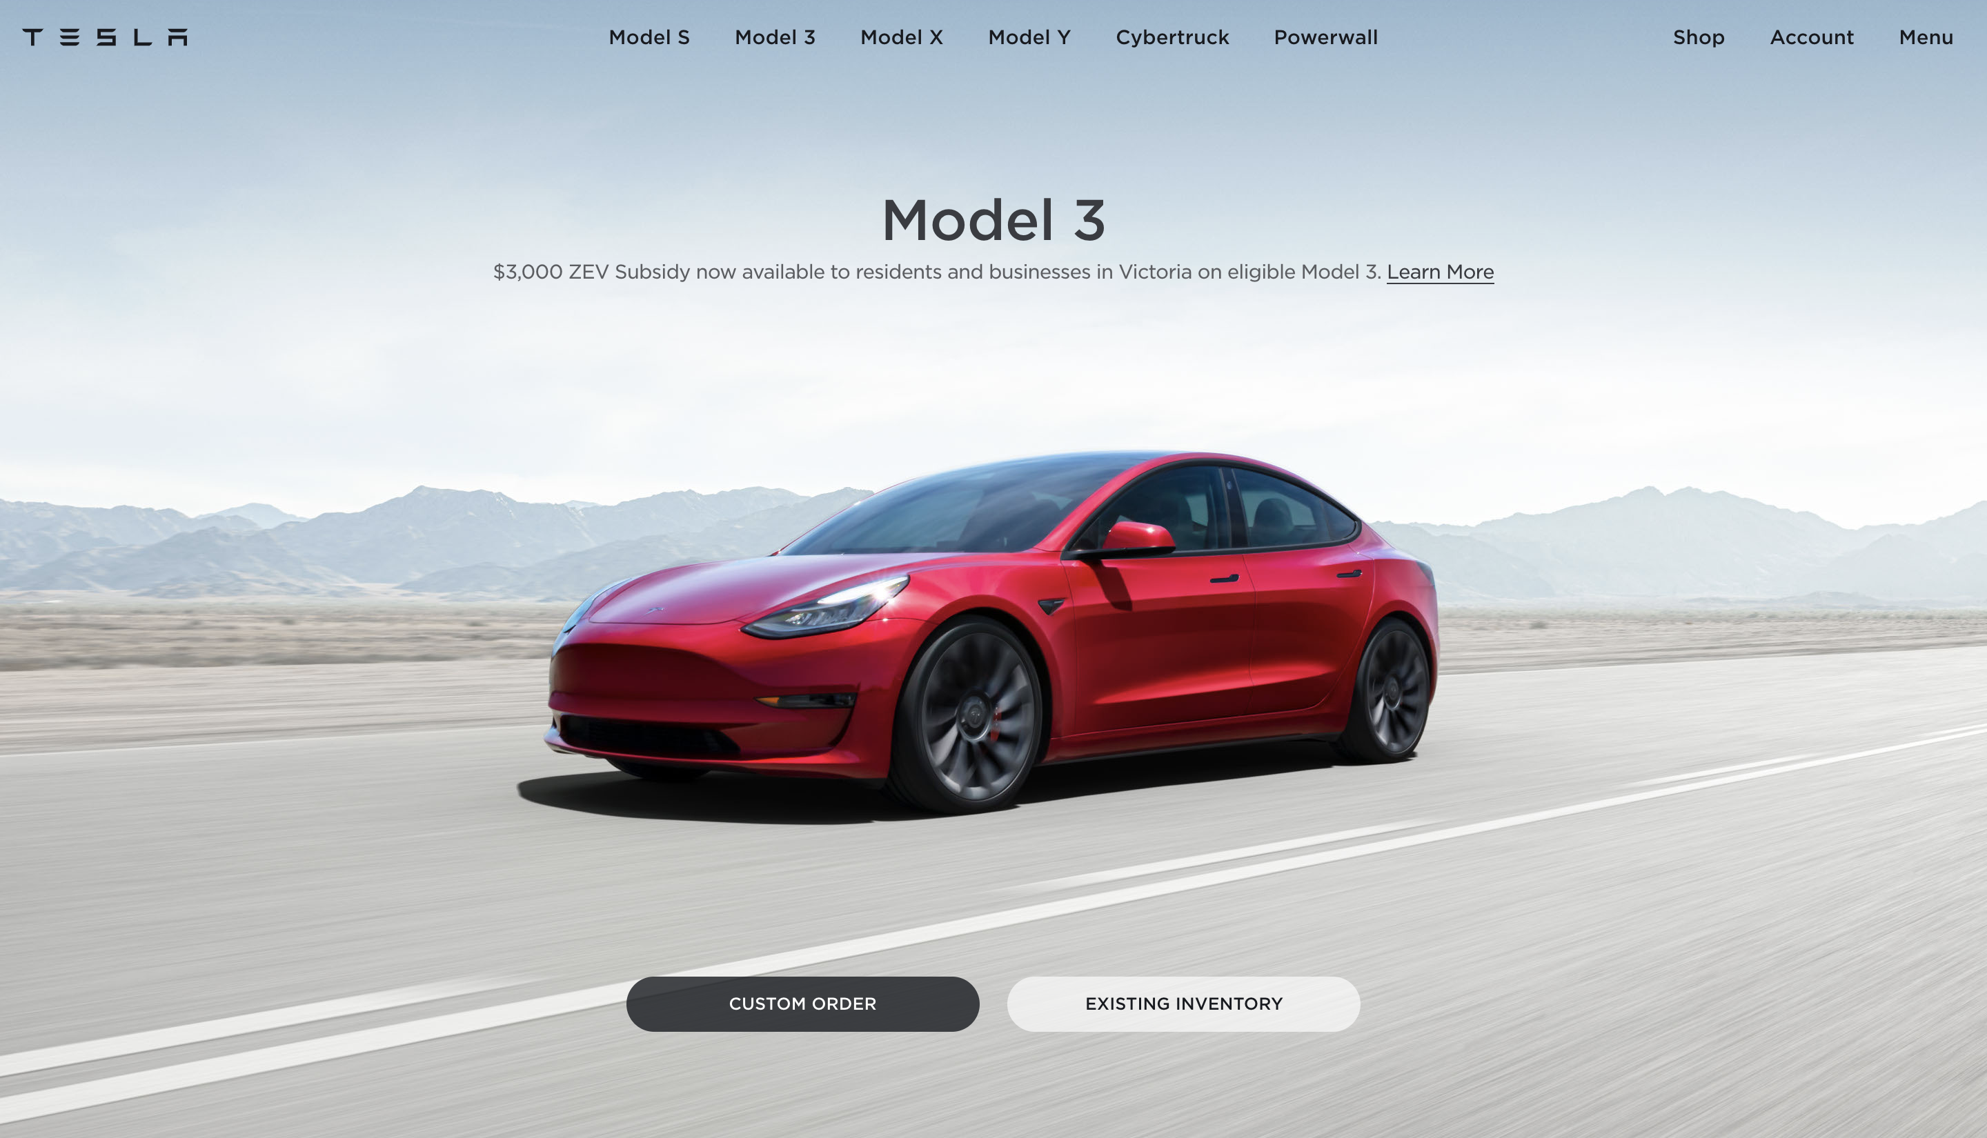

(Rolex, n.d.)

This look is very stylish and modern looking. These pages exude quality and legitimacy.

What these pictures don’t show is the interaction between the user and the site. Animations in these pages are very simple, and quick, yet they feel impressive. Users can see feedback when hovering over elements and content is gracefully animated into the screen upon scrolling. These features may be something which I try to emulate in my own website.

# Introducing the Target Audience

Healthy adults, 21 to 45 are targeted to come stay at the Moons of Mars resort. The target audience for this resort could be described as **curious**, **daring** and **youthful**. Our clients are likely to be among elite professionals, world-class athletes, and the rich & famous. The majority of our target audience are without children and free from major responsibility outside their work. The pricing of the resort is affordable to the upper middle class, with most being considered wealthy.

Although the option of resting and relaxing is available, the intention is for customers to engage in more physical activity such as exploration and jetpacking. This is why I have decided to target healthy adults no older than 45. There are also risks involved in space travel and being far from home which have to be considered. All participants must be 21 to ensure they are mature and capable of making responsible decisions. Below I have created some personas in an effort to realise the audience.

## Personas

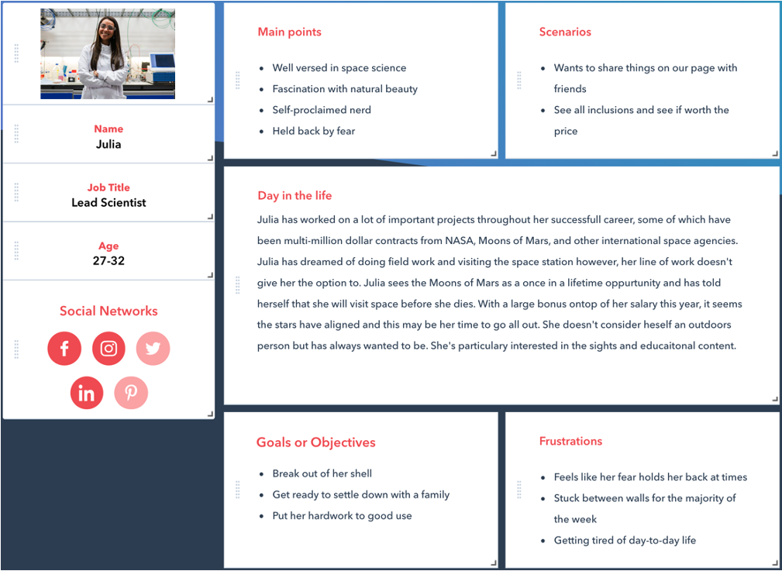

(Hubspot, n.d.)

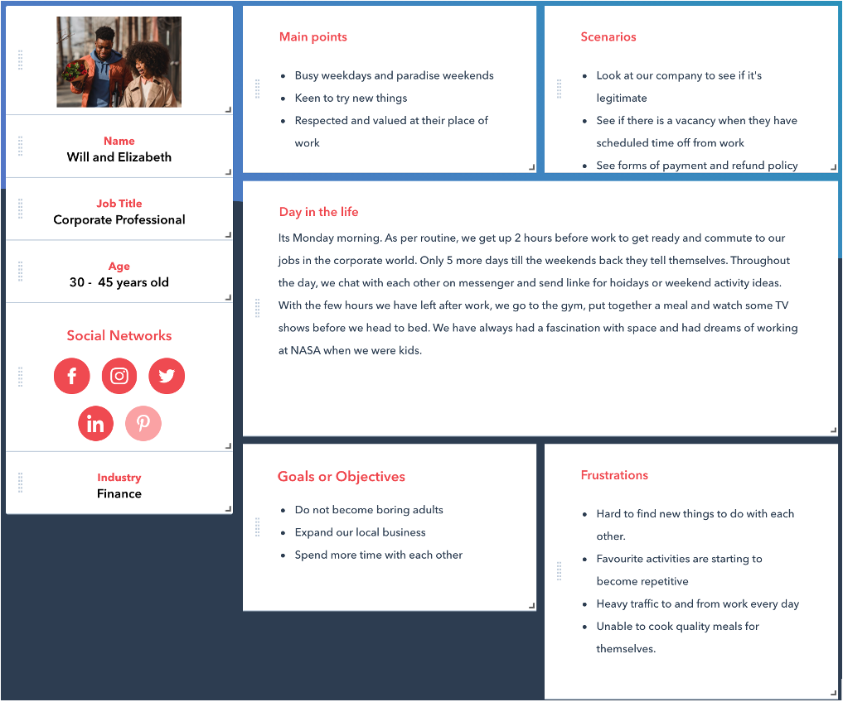

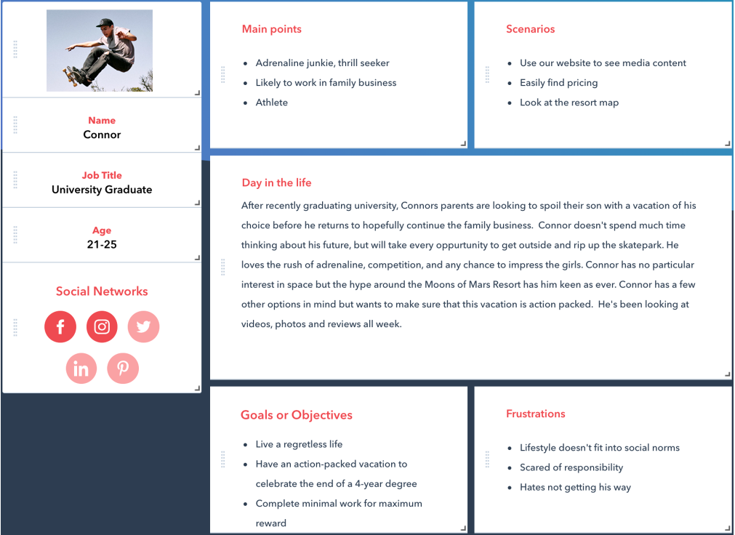

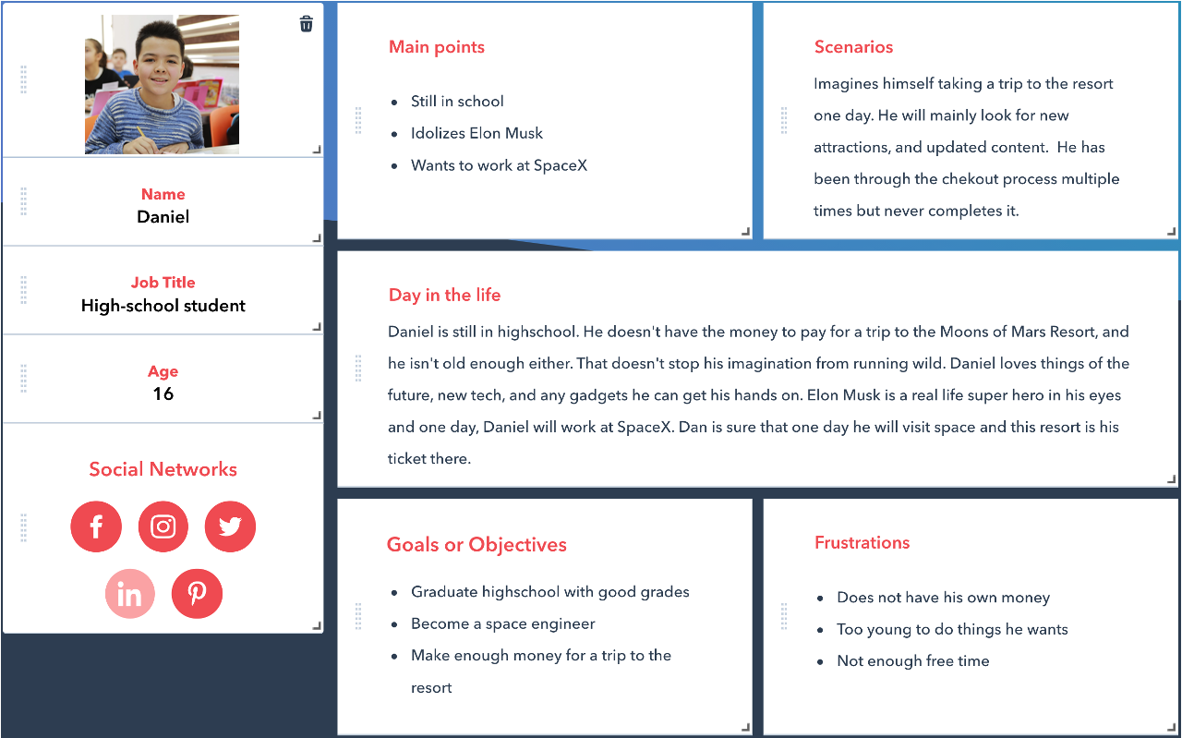

## Implications of Target Audience

The website must satisfy the expectation of the audience. It must show a strong sense of legitimacy and grandeur. It needs to the appeal to the imagination of the user and produce excitement and wonder. If we split our target audience into two main groups: **thrill seekers and space enthusiasts,** we can breakdown what our audience can expect.

To cater for the space enthusiast, we need to have a futuristic, modern looking design. These types of customers are expecting our company to be on the bleeding edge of technology. A lot of this can be achieved by simple animations, clean looking interfaces and good use of whitespace. Inspiration for this type of user can be found on the NASA, SpaceX, Apple and National Geographic webpages. In terms of interactions, they need to be fast, precise, and tidy in order to impress the audience and complement the content. Overall, I am aiming to create something Iron Man-esque for this kind of user.

For the thrill seeker, we need create a sense of excitement and thrill. Breathtaking images and video upfront can be used draw this user in. The resort has to be marketed to this user as something unlike any other, action-packed and exclusive. A trip to the resort has to be something comparable to climbing Mount Everest or touring the Amazon Rainforest. I will be looking at sporting pages, Red Bull and Formula1 for inspiration. This type of user needs to feel like this is something they cannot miss out on.

In general, I expect the design to be something dark (to go with the space theme), yet positive and welcoming. I want a lot of images and moving elements to keep the user engaged. The user experience has to feel elite and modern. I will try to use minimalism to create this, similar to how Tesla display their cars. I expect this vision to grow and become more specific through the design process.

Navigation & Organisation

# Graphical user interface, application Description automatically generatedCard Sort User Test

I conducted a card sort to figure out users’ priorities. In this test, I was able to gain some insight into what information is valued on my page. With the feedback gained in this test, I am able to better organise the information on the website.

I prepared pre-defined groups for a closed card sort. This test was conducted informally, and we encouraged the user to be open and forthcoming with their opinions.

There were a few objectives for the user in this test:

* User must sort the words into their groups
* We encourage the user to suggest cards that they think are missing
* We encourage the user to suggest edits to the cards
* We encourage the user to leave cards out of the sort if they deem them unnecessary

I prepared a testing plan which consisted of:

* An introduction to the resort and its main themes
* An outline of the closed cart sort and its objectives
* Pre-defined groups and actions to be sorted
* How I’m gathering data
* Sample follow up questions

## Results

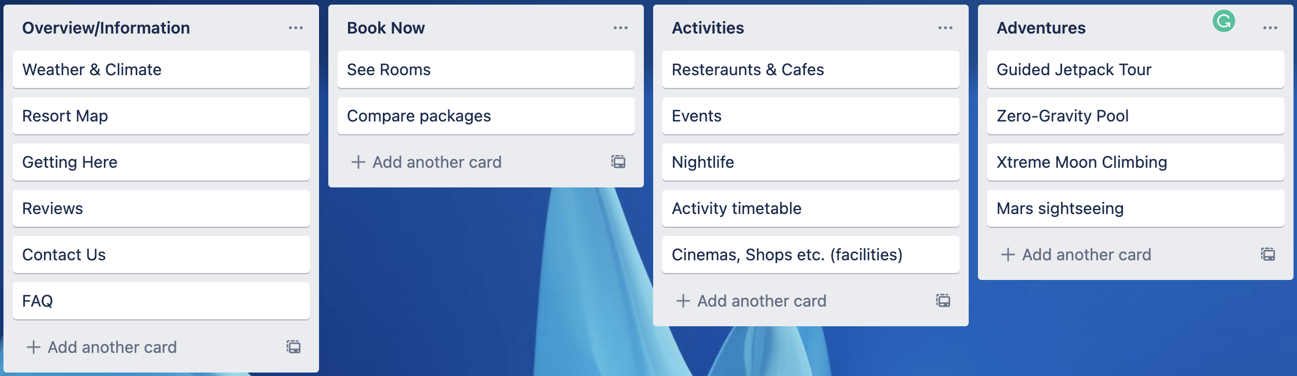

**Feedback:**

Thought that reviews were unnecessary. Found it easy to categorize the words.

Recommended that I combine and adventures and activities groups.

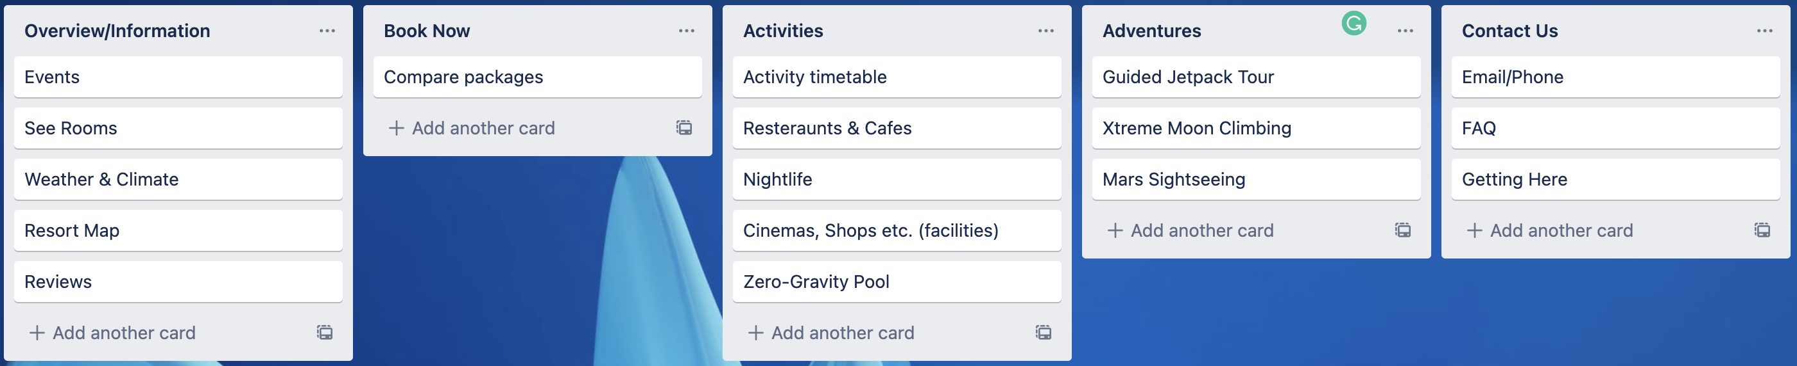

**Feedback:**

Felt that there needed to be a ‘Contact Us’ group and added the cards ‘Email/Phone’.

## Evaluation of feedback

Although each card sort resulted in a different outcome, they were all similar in how they ordered the groups from left to right, demonstrating the key groupings of information on the page, and their priority.

One interesting outcome of the user test was the addition of the ‘Contact Us’ group. Moving forward I will keep this group as it is large enough to claim multiple pages under it and should be easily accessible.

The organisational system is very straight forward and simple. The idea is that the group headings alone are enough for a user to navigate the core functionality of the site within the space of one click. If the user where to look for more detailed information, that content is at most two movements away.

# Navigation & Organisation System

In the navigation systems table discussion, we looked at several examples of good and bad navigation systems. What was clear was that effective navigation systems were simple and clean, but highly functional. Some mistakes to avoid were having too many submenus, not having clear separation between content and navigation, and having too many routes to the same action.

In my page, I am going to have a navigation bar across the top of the page because I feel this the most appropriate for the type of website I am making. I came to this conclusion after looking at the navigation systems of similar sites. Below I have some pictures of sites which I have used as inspiration for my own page.

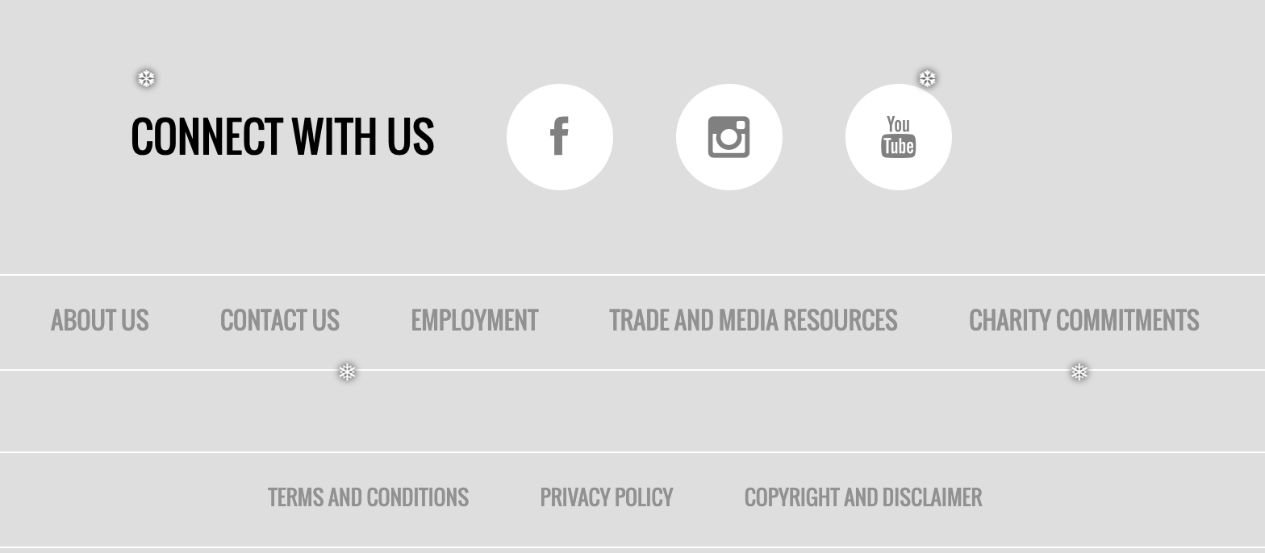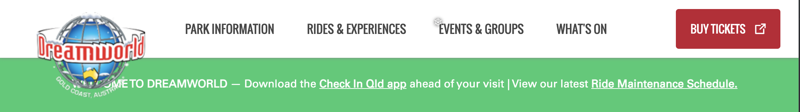

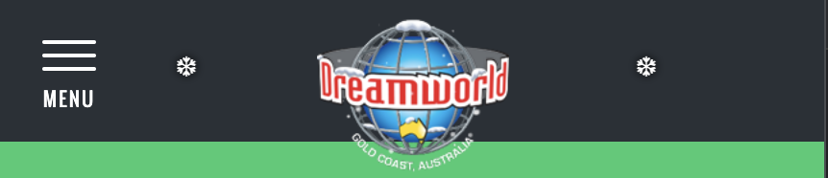

(Dreamworld, n.d.)

Dreamworld has a very simple navigation system. The main navigation bar hides into a sidebar for mobile screens. The page also has a secondary navigation system in the footer as shown to the right containing links to social media and external content.

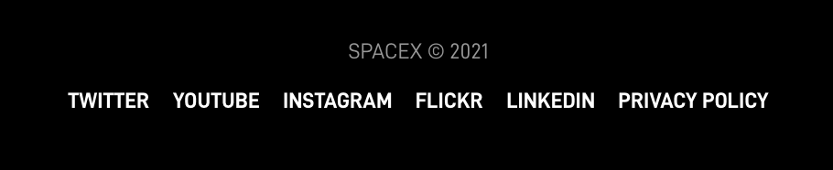

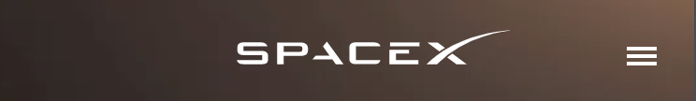

(SpaceX, n.d.)

SpaceX has probably my favourite navigation system. Apart from the sleek animations when hovering over the links, the navigation of the site is very simple and modern looking. They also have a secondary navigation bar to the right which has additional links. These items are all combined together in the mobile navigation system.

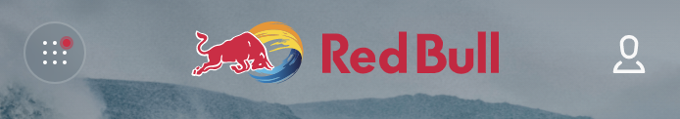

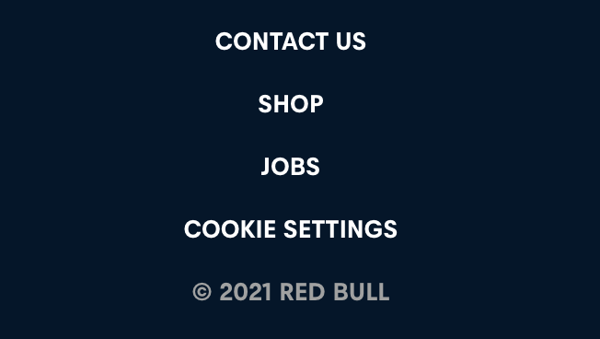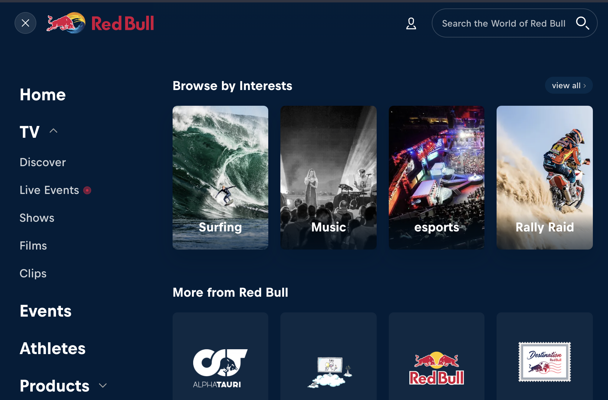

(RedBull, n.d.)

Red Bull has a very interesting navigation system that makes a good effort at making the immense amount of information on their website accessible. Unlike most websites, the main navigation links are not drop-down bars. To the left, there is a menu icon which brings down a large navigation system fitted with multiple layers of navigation. Although I do like the look of this, I feel it is unnecessary for my website.

# Site Map & Content Architecture

The diagram to the right is a sitemap representing the results from the card sort test. The user interaction will start from the ‘Welcome’ page. The underlined headings represent groups in the navigation bar, and the following pages in the next level will be in the submenus.

I also plan on having a secondary navigation bar to hold links to external pages such as social media, privacy policy, and copyright etc. I have not created a sitemap for these links as it’s one dimensional and straight forward.

As I moved forward the design process, I found that some pages were either unnecessary or I didn’t have enough time to implement them. During the Hi-Fi Prototype user test, I also encountered some issues which led me to change the sitemap to final version on the next page.

This final sitemap has had a few updates made to it since its first iteration.

Firstly, the most major change is the unification of the ‘Activities’ and ‘Adventures’. During user tests, I found that there was a lot of confusion between the groups when asked to perform a task. This change eliminates this confusion and make the navigation more efficient.

The second change is the removal of the submenu under ‘Book Now’. Although there are links to book tickets on the page itself, I found a number of users didn’t register that the group names are actionable links themselves. To make this clearer, I moved the ‘See Rooms’ page into a different group in order to make it clear that ‘Book Now’ is a clickable link.

# Paper Prototype User Test

This user test was conducted over a low-fidelity prototype made on the InVision app (Invision, n.d.). The primary focus of the paper prototype is to lay the foundations for the core functionality and contents of the website. Superficial elements such as colour, styling, or images have not yet been considered.

I prepared a testing plan containing the following:

* An introduction of the resort
* The aim of the test
* Instructions for the user
* 5 tasks for the user to complete
* Follow up questions

In short, the user was asked to look over the prototype and complete the five tasks, making sure to narrate themselves and provide verbal feedback along the way. Below will be the list of tasks to complete, follow up questions, and a few images of the prototypes (omitting images that include dropdown elements).

## Tasks

1. Find where or what you can eat.
2. Go back to the homepage.
3. Find a video of an activity.
4. Try and contact the resort.
5. Find out more about the buffet.

## Questions

These are some basic questions which prompt the user to expand on their observations. Questions similar to these were asked in the actual test.

* How did you find the flow of the information you found?
* Do you think the page could be easier to navigate?
* If you could make a change to this page, what would it be?
* Do you think there should be more or less of this object on the page?

## Paper Prototype

### Diagram Description automatically generatedWelcome Page

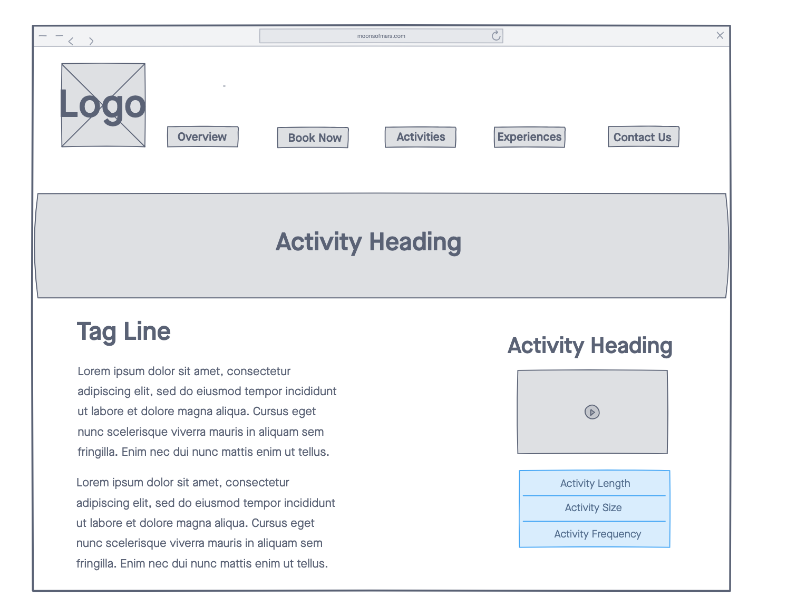

### Activity Page

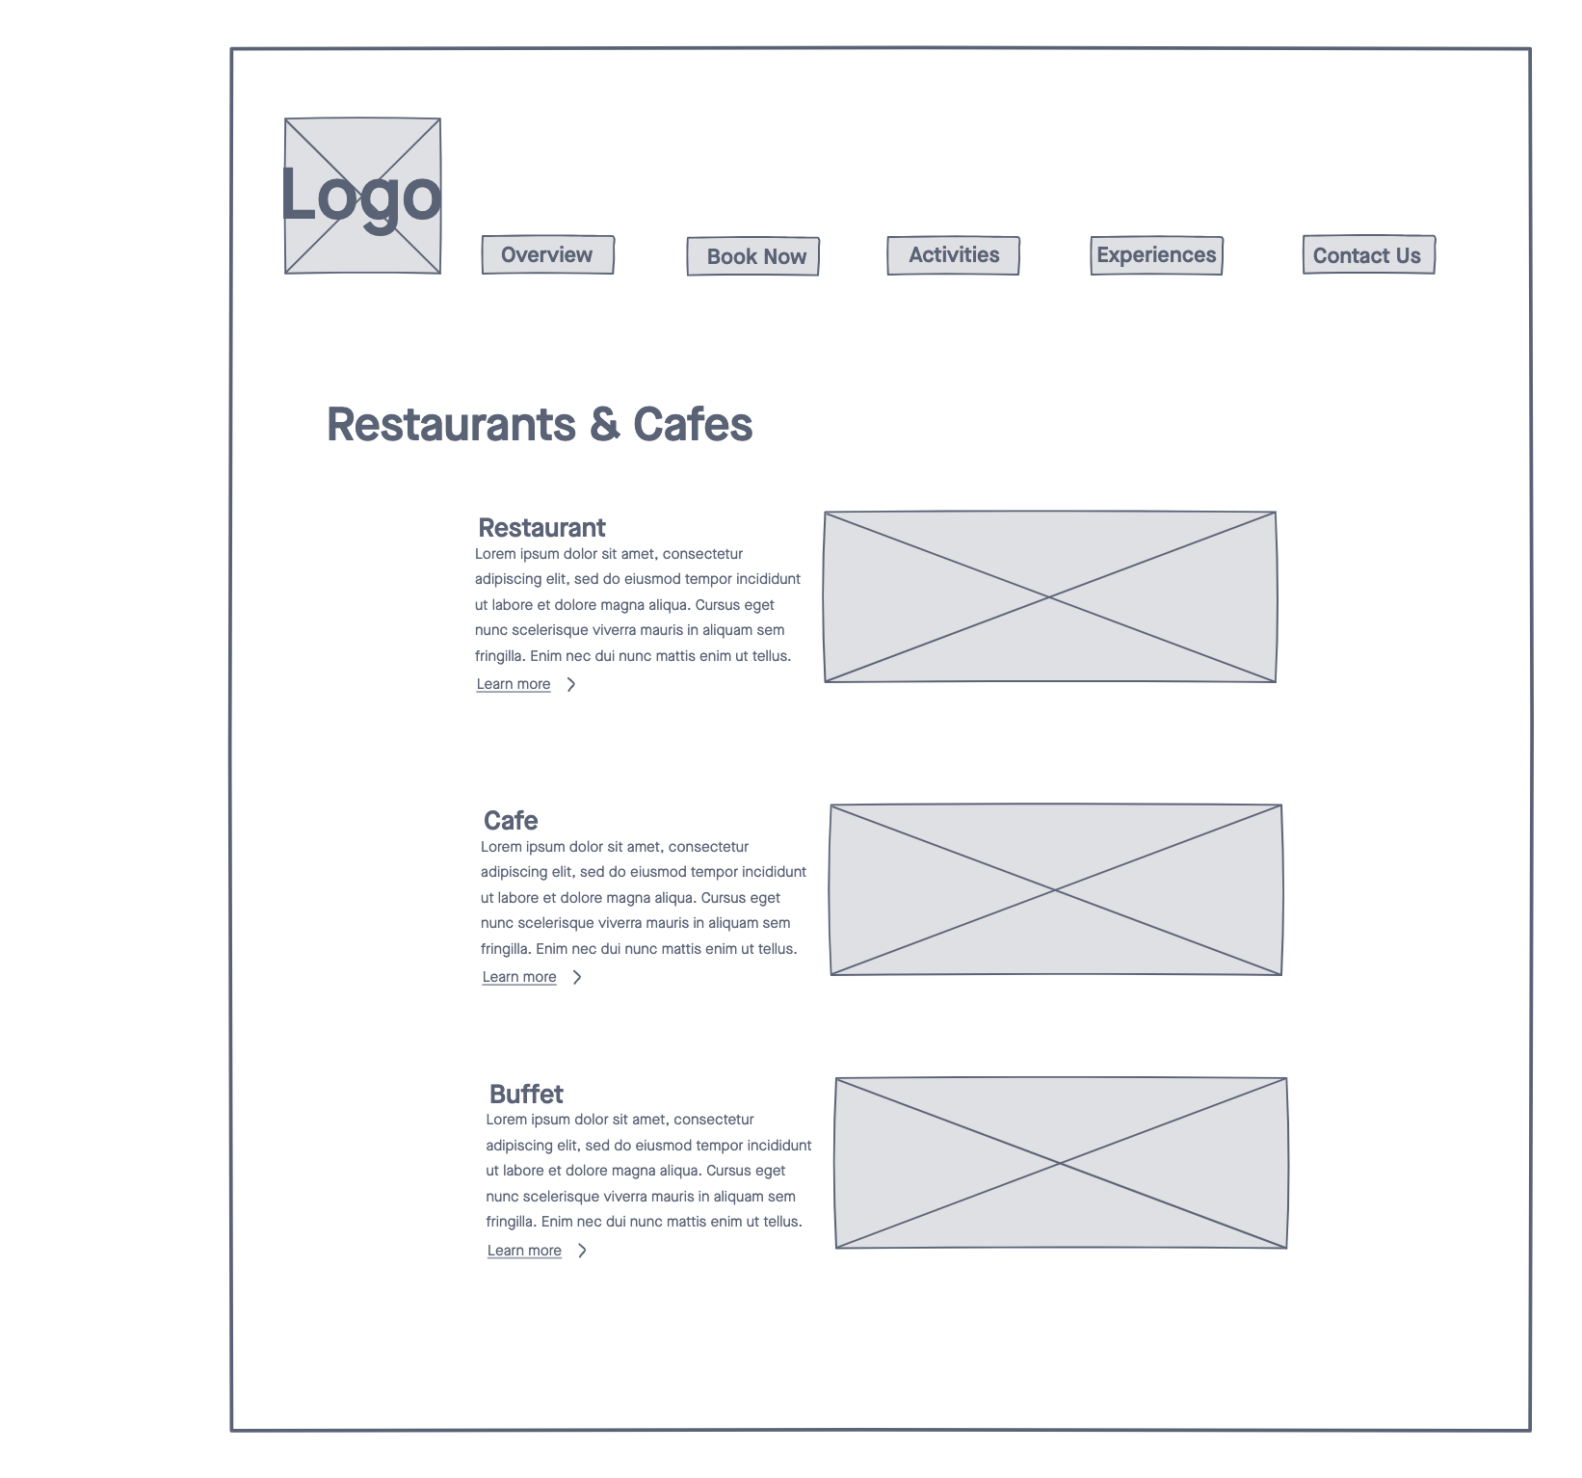

### Restaurant & Cafes

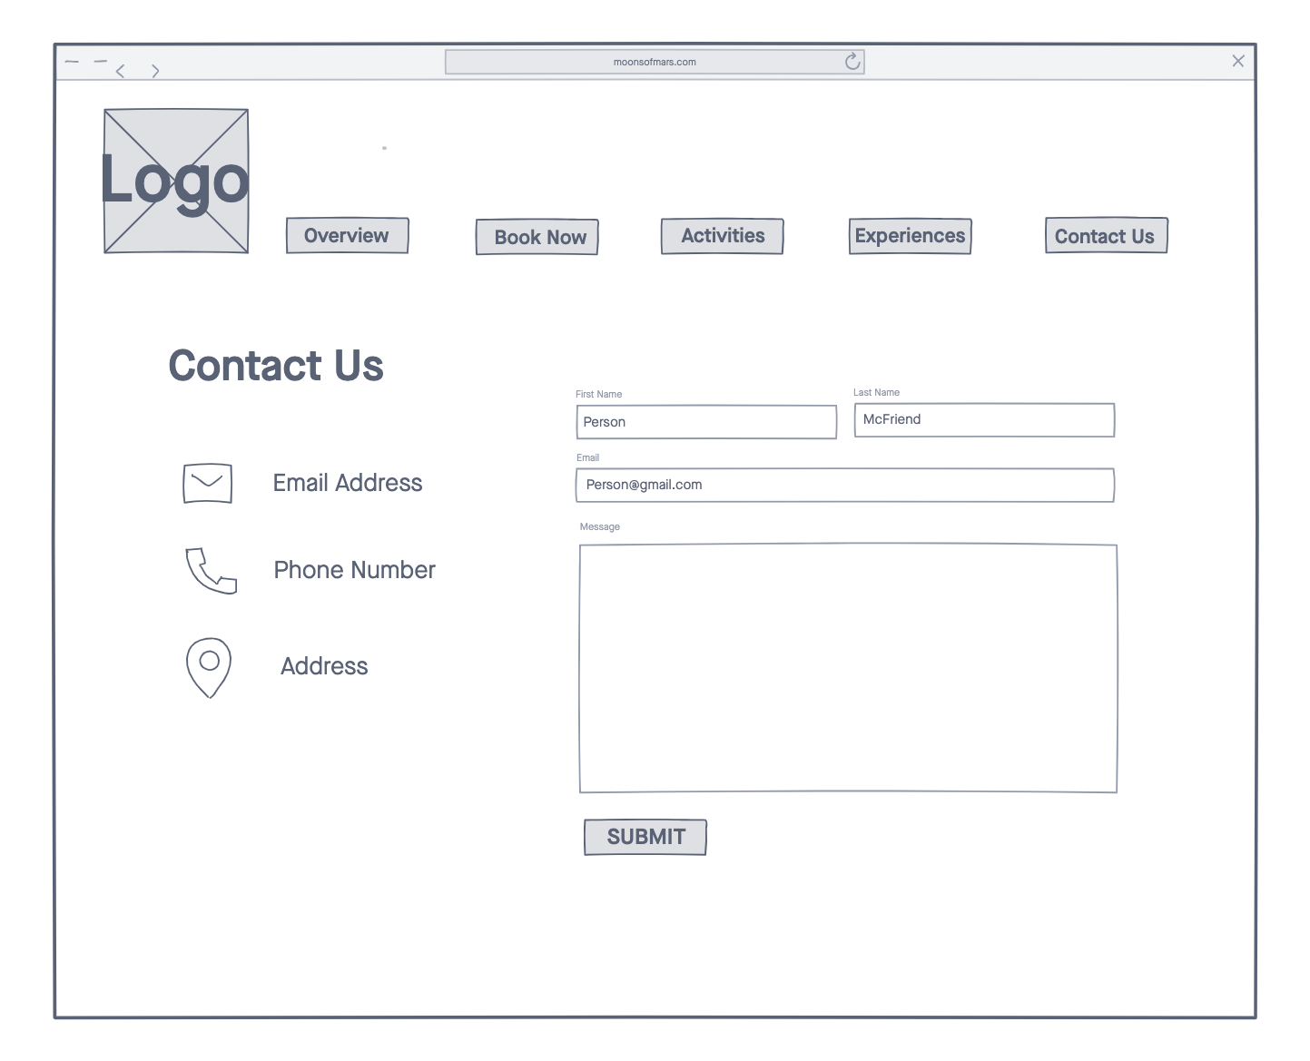

### Contact Page

## Feedback

In general, the feedback was largely positive with not many suggestions or recommendations being made. All users found the navigation system easy to use and were able to swiftly complete the tasks.

One major change that I will implement is replacing the slideshow on the welcome page with an introduction to the resort. This idea was brought about by a user mentioning that an image may not be a proper introduction to the resort and its main themes. They recommended we start the page with some text that might summarize the resort or provide some sort of welcome to the user.

Regarding the contact page, one user suggested we move the form to the left of the page as it has higher priority over the contact details. The natural order of attention is to go from left to right of the page and so it would make sense to start with the form as we want users to it in favour of the traditional methods of contact shown after.

# Visual Organisation & Interactivity

In the wireframes below, I am aiming to structure the users’ interactions on the page. I will annotate elements such as the navigation systems and interactive elements. This is all in effort to plan a website that engages our target audience.

**Hovering** on these links will reveal drop down menus. This is the main navigation system displayed on every page

Elements on the page can **animate** into their positions on scroll

Another link to book a visit, promoting the action

Welcome page introduces the resort and its main ideas.

Page footer is the **secondary navigation bar** providing **links to external pages**.

## Wireframe 2 – Navigation Bar

Although I have added annotations to the navigation bar above, I think it’s appropriate to highlight how it will display on the screen.

Likely to be name of resort

Any page on the site is accessible in >2 clicks.

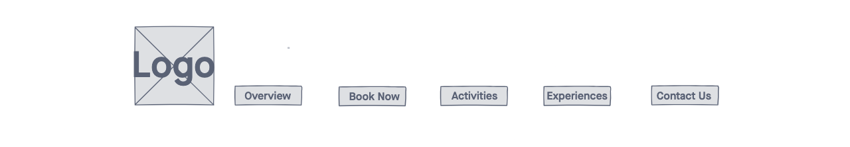

The navigation bar will show at the top of the page as the user loads the website. Upon **scrolling down** the navigation bar will hide, and upon **scrolling up** the navigation bar will show. This can be seen visually on this codepen, <https://codepen.io/Mhmdhasan/pen/mAdaQE>.

**Reinforcing** major features of the resort to make them noteworthy

## Wireframe 3 – Activity page

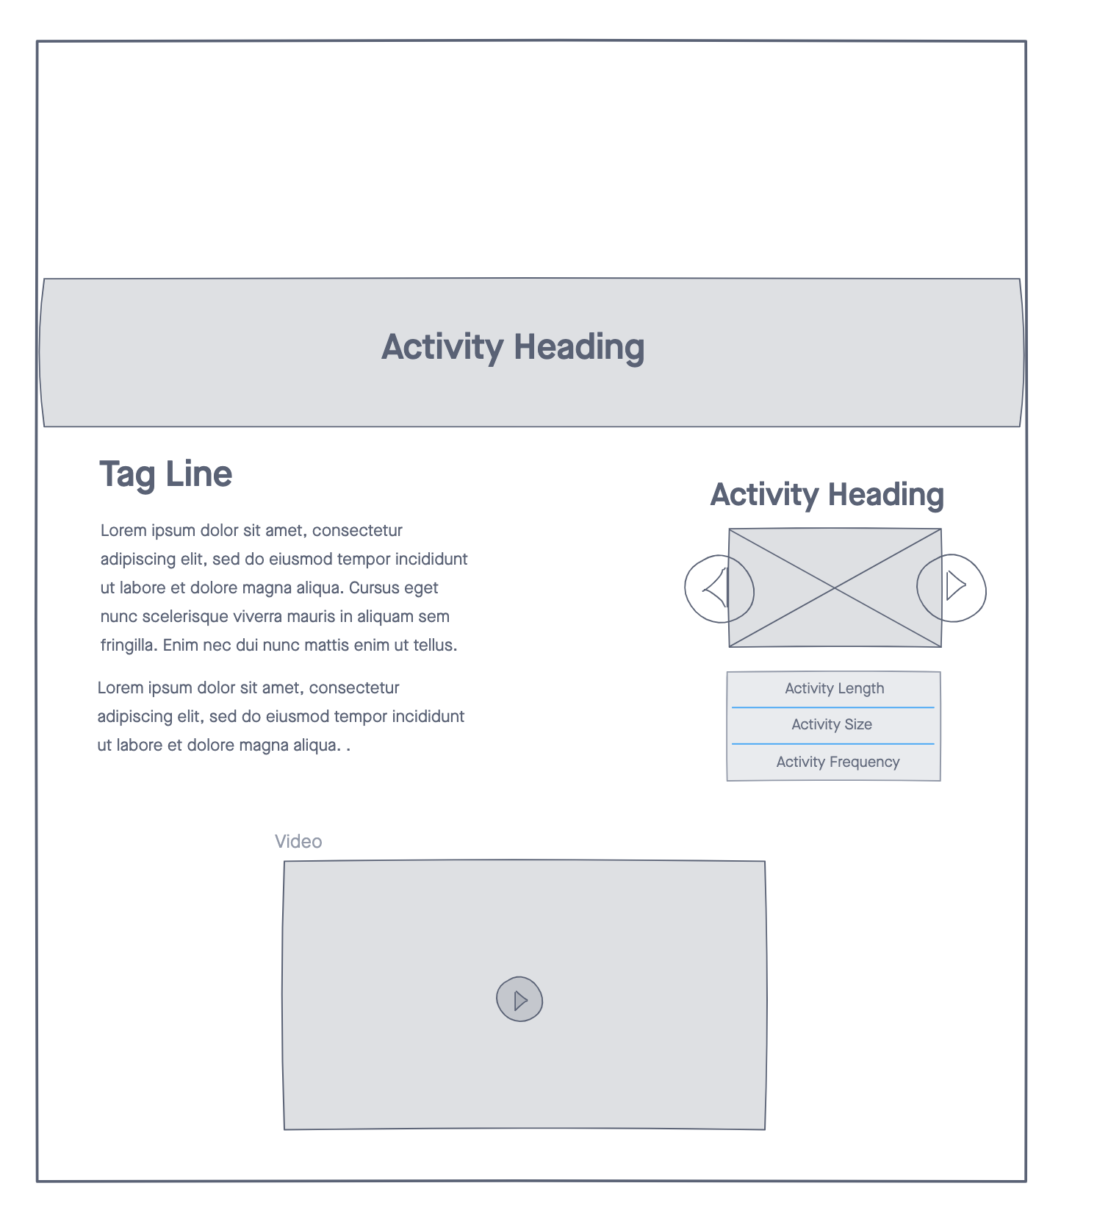

Lots of empty space creating a **minimalist, sleek and refined look**. This will add to the **user’s perception** of the resort as a legitimate and successful company.

User will be able to **interact** with this slideshow.

User can play/pause, interact with video progress bar and mute/unmute

## Wireframe 4 – Interactive resort map

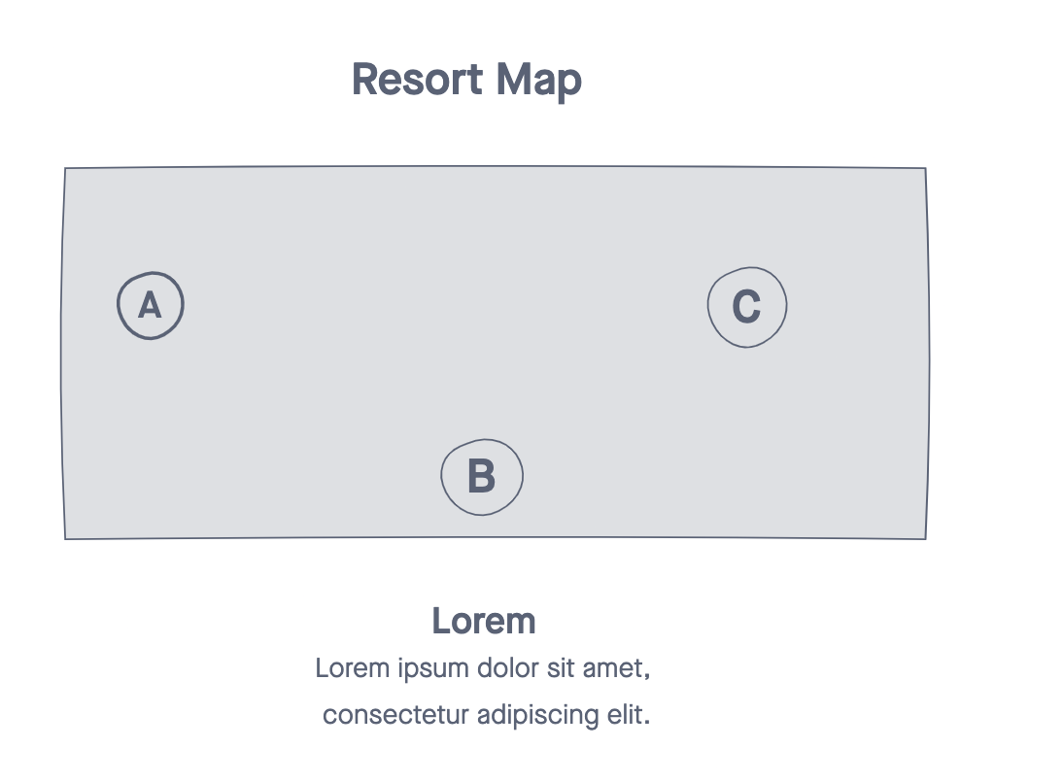

Hovering on locations in the map will show tips displaying name or other related information.

My main approach to visual organisation is to use plenty of whitespace in order to create a stylish and affluent experience for the user. As described in Wireframe 3, this can lead to a positive perception of the resort itself. Not having clutter on the page not only adds emphasis to content, but it can passively reduce stress which is what users will expect from a vacation at the resort. Nevertheless, I do not want there to be a lack of information on the website. I can avoid this by saving larger spans of information for pages deeper in the sitemap and keep information on the homepage direct and concise paired with hyperlinks to more formative content.

I feel that adding complicated interactions/animations may look unrefined or unnecessary. They also add an immature feel to the page which doesn’t pertain to the target audience. Impressive websites like Apple, Tesla and SpaceX all incorporate simple animations and interactions that work quick and sharp, however complicated they may be under the hood.

Part B

Aesthetics

# Aesthetic Prototype User Test

This user test was conducted over a medium-fidelity prototype which I prepared using PowerPoint. At this stage in the design of the website, I am starting to consider aesthetics such as fonts, colours, text sizing, consistency, and other stylistic features.

I prepared a testing plan containing:

* An introduction to the resort
* The aim of the test
* My intentions in holding the test
* Instructions for the user to follow

Prototypes of 4 pages were prepared for this test. In short, users were asked to look over the pages and provide any feedback. During the test, I tried to facilitate the discussion by prompting the user to expand on their ideas or focusing their attention on a certain element or theme. After this, I explained my choices as the designer, and we finished the test by discussing potential changes.

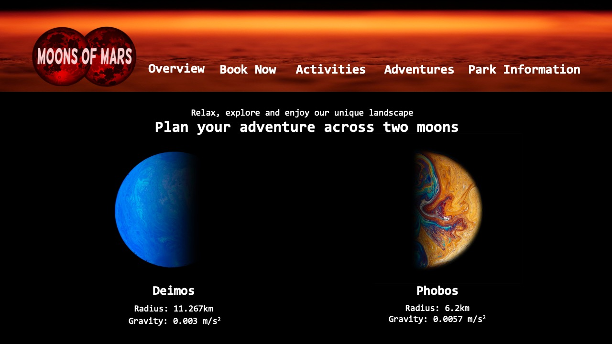

**Consolas font** which is used in programming/terminals. This creates a techy look.

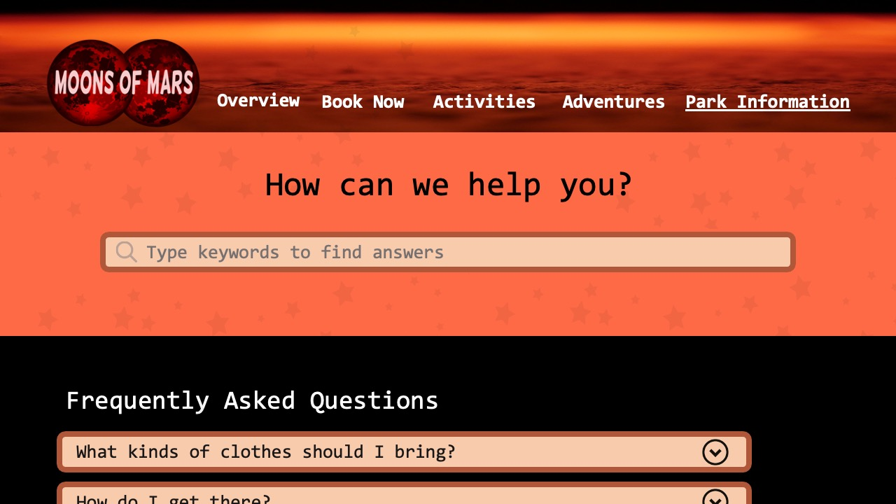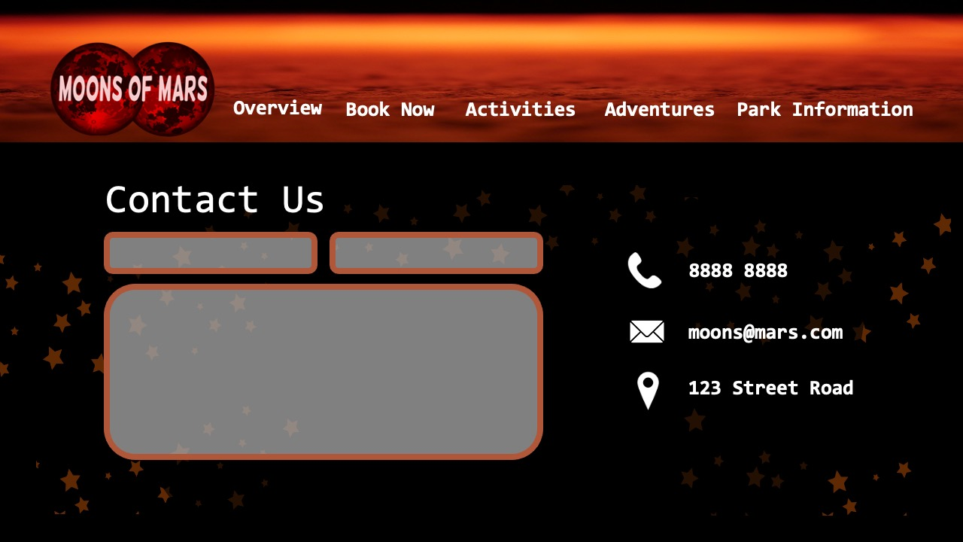

**Red and black colour palette** reinforcing the theme of mars and space

Slightly **rounded corners** – people naturally favour rounded edges however too round a button can look frivolous.

Opaque stars in the background in create a sense of quality and a night sky.

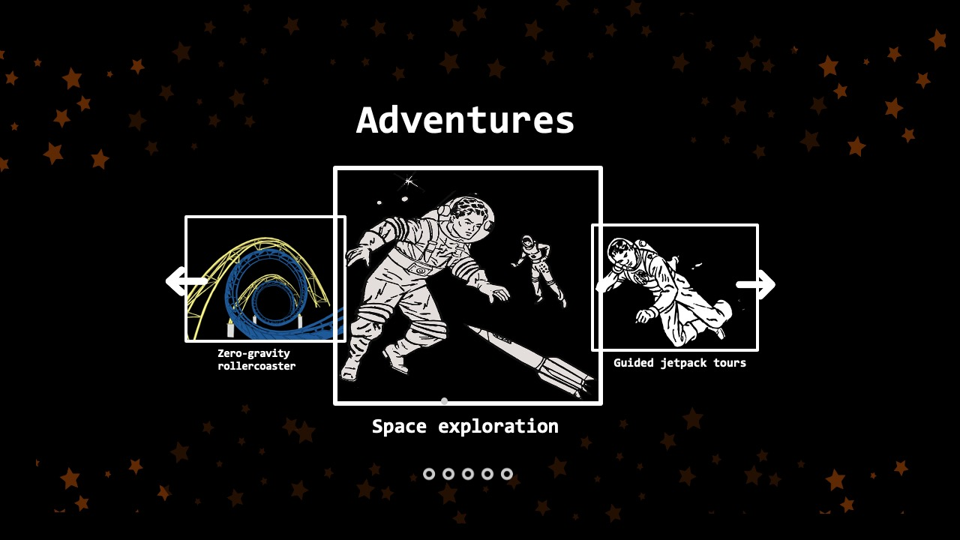

3D animated slideshow which looks impressive on the page

## Feedback

Starting with the positive feedback, a lot of users mentioned that they enjoyed the subtle stylistic features such as the opaque stars on blocks of colour which otherwise would’ve been solid. I felt these added a touch of quality to the page. Users also mentioned that they liked the structure of the pages which looked modern and futuristic.

One user made a note about how I should use one font throughout the whole page to make things look more unified. This came at a surprise as I did only use one font for the contents of the page. We came to the conclusion that were two reasons for this. The logo uses a different font which has a large presence on the page. The second reason is that seeing the same font, in the same size, on different coloured backgrounds can give the impression that different fonts are being used.

In collaboration with the user, we figured that this could be fixed by having greater separation between fonts in the viewport which was lacking on the welcome page. The links in the navigation bar were the same size as the page heading, and a few other elements on the page which disturbs the natural flow and creates confusion.

The next major point of feedback was the lack of colour. Although I initially decided to base my website around a mars red colour, it was brought to my attention that a few shades of red looks quite boring and unattractive. I can use a combination of images, text colour, and background images to add more vibrance to the page. Moving forward, I will try to expand my colour palette to include more colours, however I would like the main theme of my website to build up from a black/dark background.

# Style Guide

After receiving feedback for my draft website implementation, I decided to do some more research for inspiration. Particularly I tried to redesign the logo, introduce more colour, and bring a more real-life look to the site. This is in contrast to my aesthetic prototype which I felt was very traditional looking and didn’t effectively use images and colour.

## Mock-ups

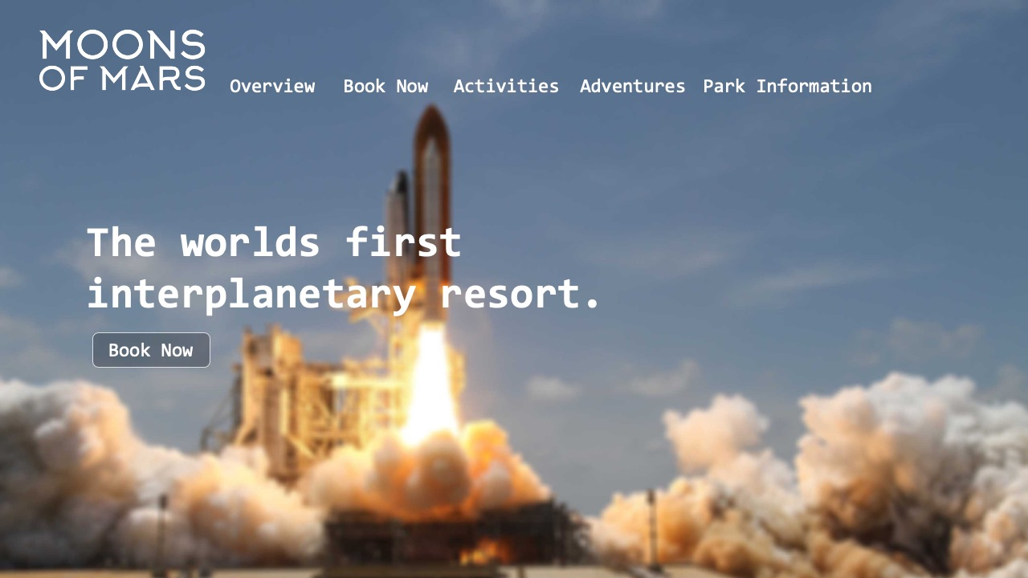

Background image covers entire viewport. Looks very immersive.

Button colour is created using opacity.

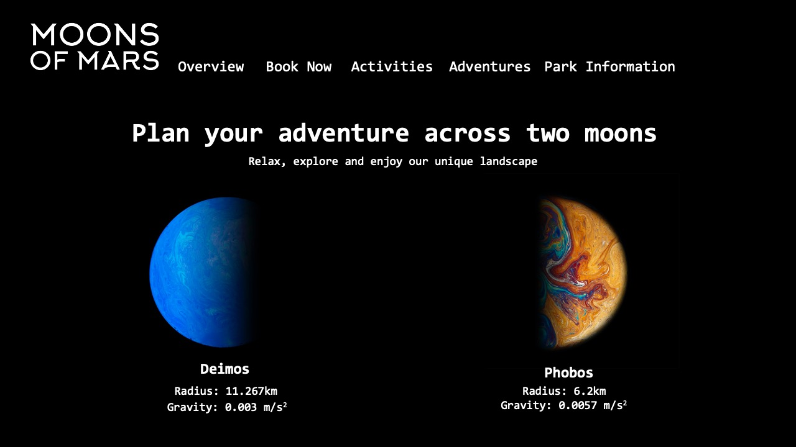

Hovering on buttons will show feedback by highlighting the clickable area.

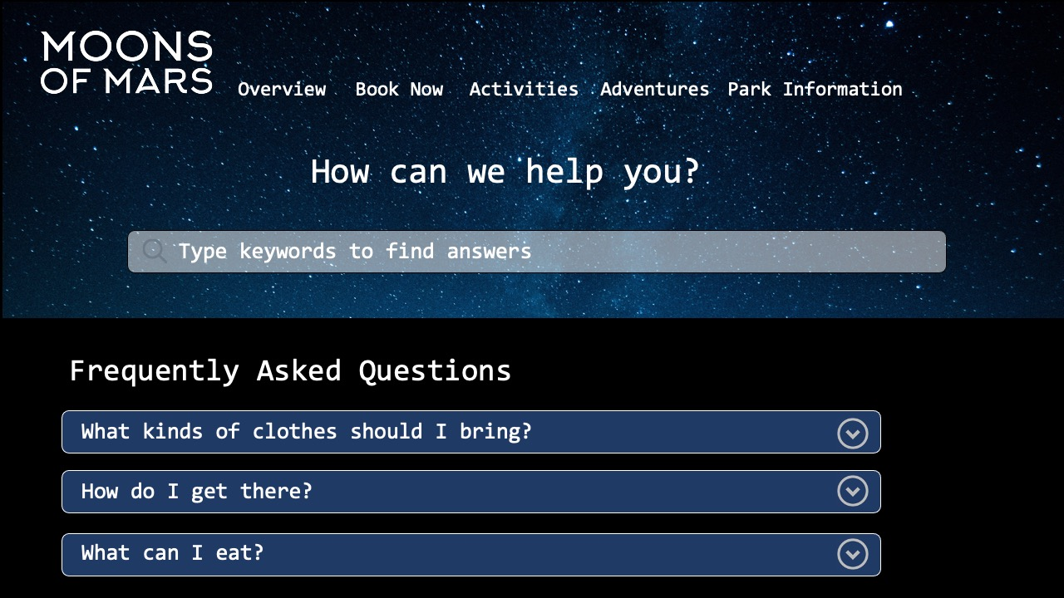

There will be a smooth and quick animation when expanding

5px border radius

Thin borders add to the light experience and improve separation.

## Aesthetic

The overall aesthetic of the website should create a visually pleasing and welcoming experience, whilst maintaining a momentous, mature and impressive feel. I want to avoid bright colours, distracting animations and anything childlike as it doesn’t appeal to our target audience. Too many distractions on the page can shift the theme of the page from hyperreality to fantasy.

Whitespace is used to create a clean and calm look, yet the minimalism adds weight to the contents of the page. Thin borders, rounded corners, and white text help to bring positive and light connotations to the page.

The use of images to cover the background is in effort to make the page more immersive and awe-inspiring. The images also add an element of realism contrasting the fantastical nature of the resort.

Animations and transitions on the page will be quick, simple, and sleek. This can help build on the quality and legitimacy of the page.

## Fonts

I’ve decided to use a font called Inconsolata, Semi-bold 600. This font is similar to Consolas or Monospace which is typically used for computer code and terminal lines. I made the choice to use this font as I think it can bring a technical, high-tech and scientific look to the page, adding to the impressive feel I am trying to create.

Title – 82px

Heading 1 – 64px

Heading 2 – 48px

## Colour Scheme

I don’t want to define a strict colour scheme because I feel it leads to a basic and restricted look. However, I plan on using a predominantly dark theme (black base colour) to create imagery around space and the night sky.

Similar to Rolex and Tesla websites, I want to use photos, videos and gradients as the background of the viewport to bring colour and light to the page. I can also use the combination of opacity and white/black shades to add depth and colour to buttons, form areas and other interactive elements.

For font colours, I want to restrict them to black or white, depending on what is visible against the background. I’m refraining from using coloured fonts because I feel they don’t appeal to the adult target audience.

## Aesthetics Table Discussion

Being a computer science student, I am not well practiced in design and UX. Because of this, my initial designs were very limited and lacked creativity. Sitting through the aesthetics lectures and table discussions brought a lot of things to my attention as areas I can improve in my own website.

I focused on creating a personality for the page which appeals to the target audience. This has to attract both thrill seekers and space enthusiasts. Not only will this personality dictate the visual aesthetic, but also the type of language I use. I’m aiming to present an exciting, stunning, intelligent personality with a hint of mystery.

Formatting text correctly can create a huge difference in useability and legibility. Dense and informative passages of texts can be formatted to look more reader friendly. Moving into the Hi-Fi prototype, I will make better use of line lengths and width to improve the reading experience.

My last major point of focus is how I intelligently use colour to draw appropriate emotions from the user. For example, I can use a purple image as the background for the welcome page to display a sense of wealth and luxury as a first impression. An activity page may make use of warm colours to bring an active and stimulating look, suggesting more energy as a result.

Functionality

# Hi-Fi Prototype User Test

In this final user test, I presented a high-fidelity prototype of the Moons of Mars resort website in order to receive feedback. Unlike the other tests, there is not particular focus in this one.

I prepared a testing plan containing:

* An introduction to the resort
* The aim of the test
* A set of five tasks
* Notes on what to watch for and follow up questions

## Tasks

1. Find out how long the ‘Guided Jetpack Tour’ goes for?
2. Get to the socials of the resort.
3. Try and find some images of the resort.
4. What kind of clothes would you need to bring?
5. Book a holiday for yourself.

While the user was completing these tasks, I was trying to gauge the useability of the page. I asked questions regarding the feel and experience of the page.

## Feedback

I was able to receive some great suggestions from the users and was able to apply the tweaks relatively easy.

**Task 1:** I found that having both ‘Activities’ and ‘Adventure’ groups in the navigation bar caused confusion. When browsing the page, the distinction may be clear, however when looking for specific information, it isn’t clear which group an item may fall into.

**Before:** 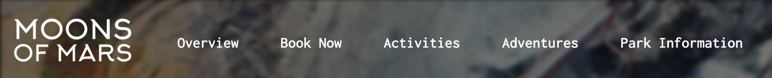

**After:**

Merged the ‘Activities’ and ‘Adventures’ tabs.

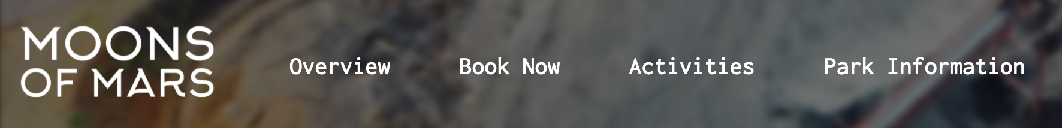

**Task 2:** The footer includes the links to social media however it is too small on the page and went unnoticed by about half of the users.

**Before:**



**After:**

Increased line height and font size



**Task 3:** This gallery was found quickly and without hesitation by every user.

**Task 4:**  Almost all the users found the answer to this question in the FAQ section of the page. Some users were clicking on the question box to expand it instead of the expand icon. I can fix this by making the entire container clickable.

Previous clickable area

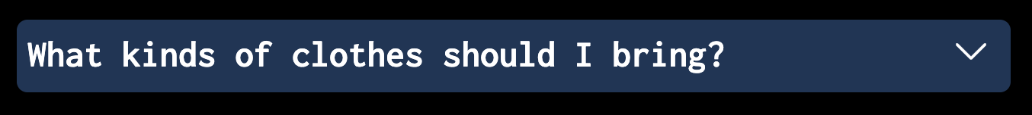

Updated clickable area

**Task 5:** Every user was able to book a stay at the resort. Some users did not realise that the ‘Book Now’ group heading is a clickable link and assumed that only submenu items are clickable. We came to the conclusion that removing the sub-elements of the group would remove that confusion.

**After:**

Removed submenu item.

**Before:**

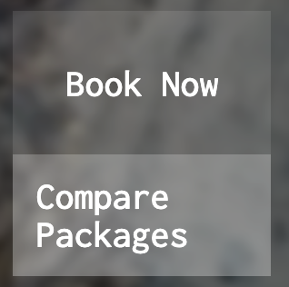

# Technical Implementation

## Interactions

|  |  |  |
| --- | --- | --- |
| **Interaction** | **Significance** | **Implementation** |
| BaguetteBox gallery | User can click on a thumbnail to enlarge the image, see a caption, and scroll horizontally for other pictures. | HTML: Put images into containers  CSS: Snap thumbnails into a grid using flex box. Use hover selector to indicate its actionable. Transitions, loading animations and controls are given by plugin.  JS: Use baguetteBox plugin and initialise. |
| Navigation bar hiding on scroll down and changing colour for better contrast. | Navigation bar will hide to free up space on the page when scrolling down. If user scrolls up to find nav bar, it will transition back into the top of the page. Background colour of nav bar will change colour for better contrast whilst not at the top of the page. Very convenient and looks impressive. | CSS: Set position as fixed and top: 0  JS: Create function on window scroll. Select header element in the DOM. Use conditional if/else statement to change top position and background colour based on scroll position. |
| Booking form validation and personalised confirmation message. | Form fields will change colour to visually represent invalid inputs. After submitting form, screen will show a personalised booking confirmation thanking user by name. | CSS: Select form items with error class and style with red border and red text.  JS: Use conditional statements to check form elements.  Add error class when invalid input is detected.  Remove error class when user corrects the input.  Use var to store name and manipulate innerHTML to remove the form and show confirmation. |
| Snap scrolling with dots showing users place on the homepage.  (Kobayashi, 2021) | Sections will snap into place on the screen when user scrolls. User will also be able to see a vertical set of dots which indicate all sections and highlight the current one.  This improves the reading experience and user will never be stuck between two sections as intended. The dots also signal that more content is available on scroll. | HTML: Create dots to the right edge of the page. Dots are buttons which link to section ID’s.  CSS: Allow smooth scroll behaviour. Use scroll-snap-align property on sections to allow snapping.  Style dots on hover and active with a combination of transform, transition.  JS: Add dots to page when page has loaded.  Change active dot according to the active section in the window. This can be done by toggling an active class. |

## Responsive Design

When creating my draft website, I thought the best approach would be to start with the mobile implementation, and then expand for desktop users. Given more time, I would have continued this approach as mobile users are becoming increasingly popular. According to Broadband Search, about 83% of social media usage is from mobile (Broadband Search, 2021) which is somewhat indicative of the types of user on my website. Due to how the marking is conducted for this project, I decided to focus on the desktop implementation in order to maximise my marks.

I found myself using flexbox more in anticipation of restructuring for the mobile user. Flex-direction and flex-wrap properties in particular made this process much easier than if I were using some other type of display property.

## Accessibility

I was unable to implement any major features to target a certain disability group however I did make choices to improve the general accessibility of the page.

I made a better effort to improve the quality of my alt tags to be more descriptive and useful. This is beneficial to visually impaired readers.

For the navigation bar, I added a background (previously transparent) on scroll to increase the contrast respective to the body content. This was in order to improve legibility.

## Progressive Enhancement (PE)

I presented on this topic during table discussions.

I incorporated PE into my website by building pages from the bottom up ensuring core functionality is available in the case that there is a failure on the client’s side. Initially, I had planned on using JavaScript to expand on FAQ’s however, after this discussion, I understood the importance of making that information available in instances where JavaScript isn’t available

Conclusion

If I was given another chance to redo this process, I would take more time to research and document sources of inspiration. This would have put me in a position to make better choices. A notable struggle towards the end of the project was finding more complex, meaningful interactions. I would’ve started by finding interactions that could better display my skills as a developer (in effort to increase my marks) , and then form my website topic around this.

My learning strategy has remained relatively the same. Having had programming experience in the past, it was easier for me to search for help and fix bugs. An improvement could be made during tutorial sessions where I didn’t make a good enough effort to take notes during table discussions regarding unfamiliar topics such as aesthetics and accessibility. In hindsight, I could have benefited from doing more research regarding the psychology of aesthetics.

Finally, I feel the implementation of the website was a success. Although I was unable to implement as many pages and styles as I had hoped to, the core functionality of the website is there, and the user experience is rather pleasing.

References

Broadband Search. (2021). *Mobile Vs. Desktop Internet Usage (Latest 2021 Data)*. BroadbandSearch.net. Retrieved from https://www.broadbandsearch.net/blog/mobile-desktop-internet-usage- statistics#:~:text=About%2083%20percent%20of%20social,percent%20fro m%20desktops%20or%20laptops.

Disney. (n.d.). Disneyland.disney.go.com. Retrieved from https://disneyland.disney.go.com/.

Dreamworld. (n.d.). *Dreamworld | Dreamworld Theme Park*. Dreamworld.com.au. Retrieved from https://www.dreamworld.com.au/.

Hubspot, Inc. (n.d). *Make My Persona*. Hubspot.com. Retrieved from https://www.hubspot.com/make-my-persona.

InVision. (n.d.). Invisionapp.com. Retrieved from https://www.invisionapp.com/cloud/prototype.

Kobayashi, Y. (2019). *Navigation dots* [Online Image]. Github.

RedBull. (n.d.). *Red Bull Gives You Wings - RedBull.com*. Redbull.com. Retrieved from https://www.redbull.com/au-en/.

Rolex. (n.d.). *Official Rolex Website*. Rolex. Retrieved from https://www.rolex.com/.

SpaceX. (n.d.). *SpaceX*. SpaceX. Retrieved from https://www.spacex.com/.

Tesla. (n.d.). *Electric Cars, Solar & Clean Energy | Tesla*. Tesla. Retrieved, from https://www.tesla.com/en_au.

* Images used in prototypes are referenced in website implementation.